

DEPARTMENT OF CYBER SECURITY

STUDENT NAME: TALAHA FAROOQ
REG # 232123
SECTION: BSCYSev-V-A
SEMESTER PROJECT - 2
COURSE: ETHICAL HACKING & DEFENSE
SUBMISSION DUE DATE: 19/10/2025
SUBMITTED ON: 19/10/2025
Program link: bugcrowd.com/engagements/atlassian

Table of Contents
1. Passive Reconnaissance 3
1.1 WHOIS Enumeration 3
1.2 Shodan Analysis 4
1.3 DNS Enumeration 4
2. Active Reconnaissance 5
2.1 Admin.atlassian.com 5
2.2 marketplace.atlassian.com 7
2.3 Bamboo.otiselevator.com 8
3. Host Discovery 9
3.1 Admin.atlassian.com 9
3.2 marketplace.atlassian.com 10
3.3 bamboo.otiselevator.com 10
3.4 IP Fingerprinting 11
4. Asset Gathering 13
4.1 admin.atlassian.com 13
4.2 marketplace.atlassian.com 15
4.3 Bamboo.otiselevator.com 16
4.4 Assets (atlassian.com) 18
5. Scanning – all targets 20
5.1 Using nuclie scans 20
5.1.1 admin.atlassian.com 20
5.1.2 marketplace.atlassian.com 21
5.1.3 bamboo.otiselevator.com 22
5.2 Using nikto scans 23
5.2.1 admin.atlassian.com 23
5.2.1 marketplace.atlassian.com 24
5.3 Comparison 25
6. Directory Bruteforcing 26
7. Technology Detection 28
8. Parameter Gathering 30
9. Firewall Technology 33
Conclusion 35

1. Passive Reconnaissance

1.1 WHOIS Enumeration
During passive reconnaissance, WHOIS data was queried for atlassian.com. This base domain serves as the parent for multiple Atlassian services including:
- admin.atlassian.com
- marketplace.atlassian.com
- and others.
The WHOIS response confirms the domain is registered with MarkMonitor Inc. and maintained by Atlassian Pty Ltd, Australia. DNS hosting is handled by Amazon Route 53, as evidenced by the AWS name servers (*.awsdns-*.org), indicating a centralized infrastructure for DNS and domain handling across Atlassian’s public-facing assets.
Key WHOIS Details:
- Registrar: MarkMonitor Inc. (IANA ID: 292)
- Registrant Organization: Atlassian Pty Ltd
- Registrant Country: Australia (AU)
- Registrar Contact: https://www.markmonitor.com/contact-us/
- Abuse Contact Email: abusecomplaints@markmonitor.com
- Name Servers:
  - ns-112.awsdns-14.com
  - ns-1388.awsdns-45.org
  - ns-2018.awsdns-60.co.uk
  - ns-595.awsdns-10.net
This data helps validate ownership and allows for confident association of reconnaissance across subdomains.
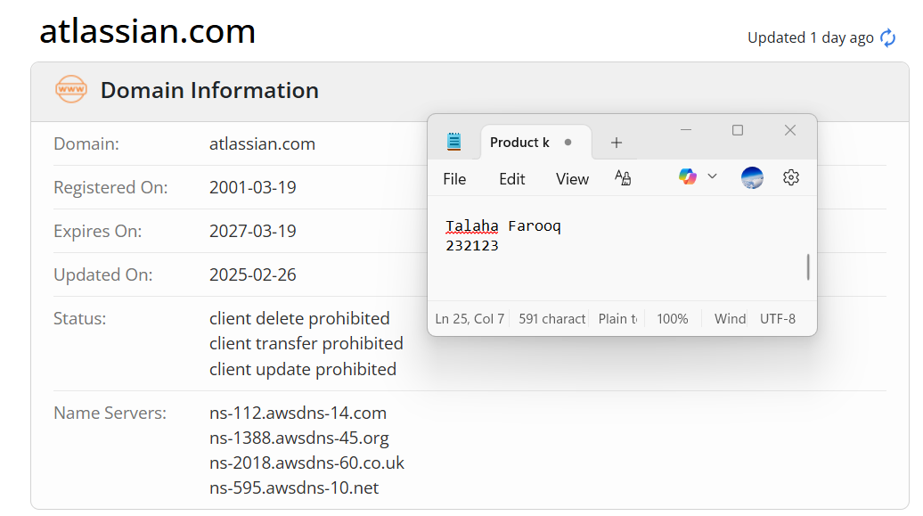
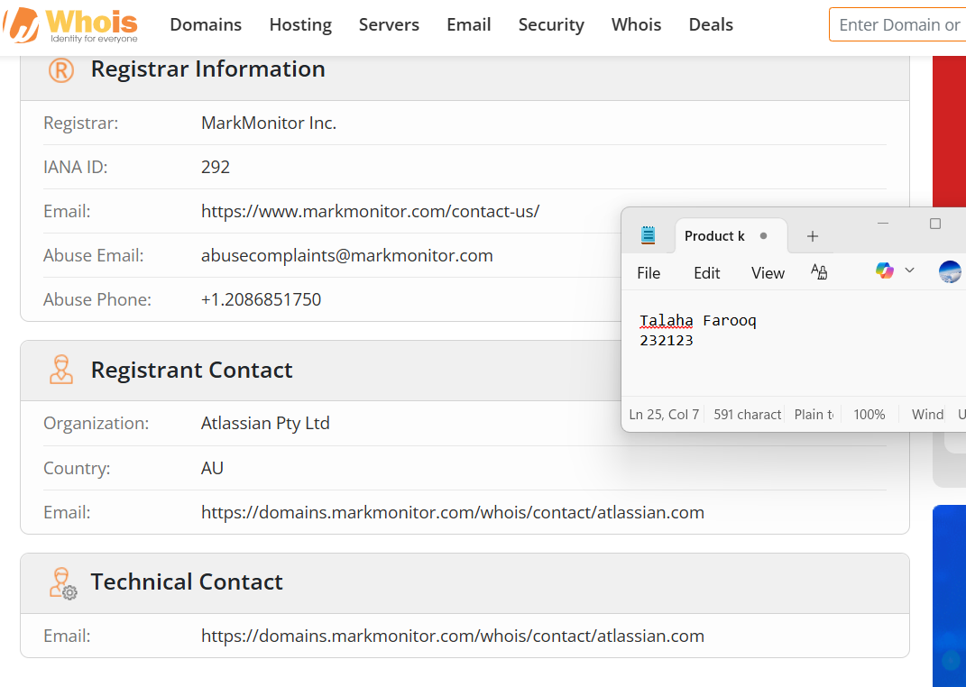

1.2 Shodan Analysis
https://www.shodan.io/search?query=marketplace.atlassian.com
Out of my all targeted sites the site marketplace.atlassian.com shows alot of data and further ips and certificates to begin and also some 3rd party softwares associated with different locations.
Narrowed Target list:
Target | Type
admin.atlassian.com | Atlassian
marketplace.atlassian.com | Atlassian
bamboo.otiselevator.com | Partner (low)

1.3 DNS Enumeration
To map DNS records and gather passive intel, dig queries were issued across several target and related domains. The objective was to identify DNS types (A, TXT, MX, CNAME, etc.), resolve potential hosting/IP insights, detect third-party services, and extract configuration details like SPF, DKIM, or verification records.
Key Findings:
- admin.atlassian.com, marketplace.atlassian.com resolved to multiple AWS IPs in the 143.204.x.x and 13.227.x.x ranges — indicative of AWS CloudFront or EC2 edge deployments.
- bamboo.otiselevator.com resolved to 104.214.227.230, confirming hosting outside Atlassian infra (likely Azure).
- TXT records for gxsoftware.com showed numerous third-party integrations (Zendesk, Apple, Microsoft, Figma) — useful for third-party attack surface mapping.
- yma.gx.nl resolved to 193.173.25.23 — passive inclusion for indirect relationships.
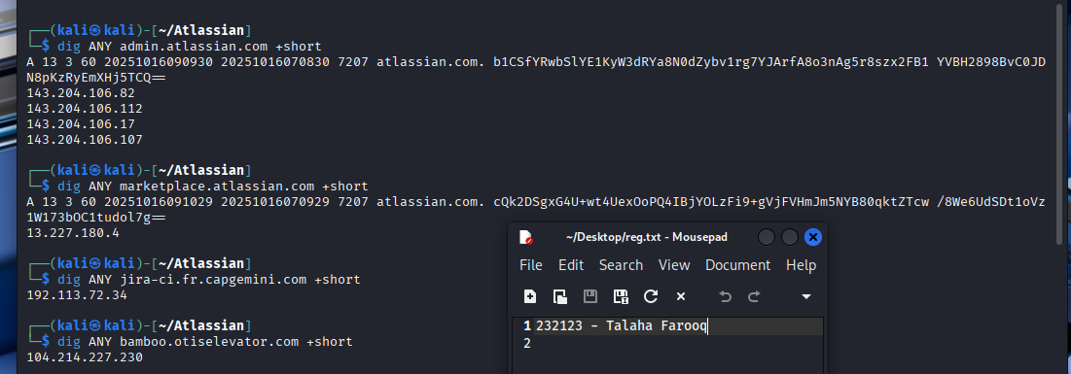
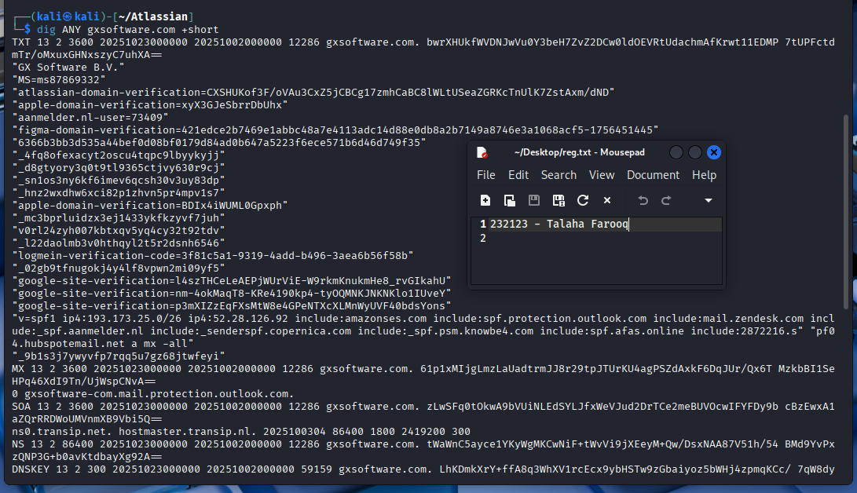
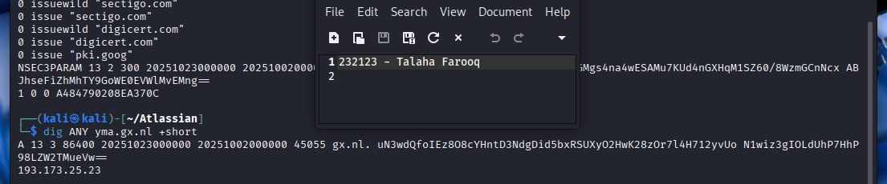

2. Active Reconnaissance

2.1 Admin.atlassian.com
Host Discovery: Ping & Traceroute
A combination of ICMP pings and tracert revealed the domain resolves to CloudFront nodes in the 143.204.106.x range, confirming it's served via AWS's CDN.
Observations:
- Ping latency was low, with consistent TTL values and 0% packet loss.
- Traceroute hit multiple ISP nodes before routing through CloudFront (*.mct50.r.cloudfront.net), reinforcing that origin IPs are hidden behind AWS infrastructure.
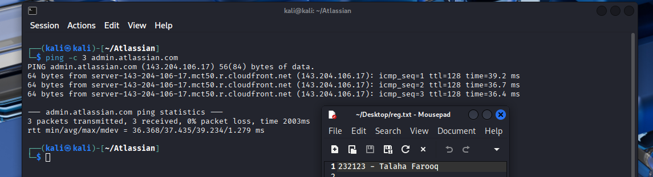
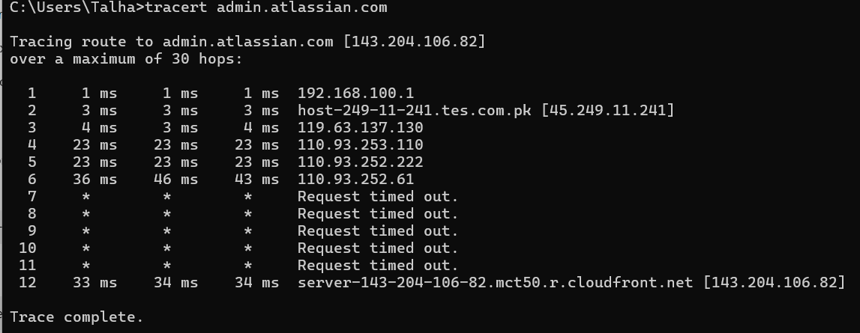
Subdomain Enumeration via Subfinder
Passive subdomain enumeration via Subfinder revealed over 830 Atlassian subdomains, many with .saas.atlassian.com structure — indicative of Atlassian’s enterprise deployment environments (prod, stage, dev).
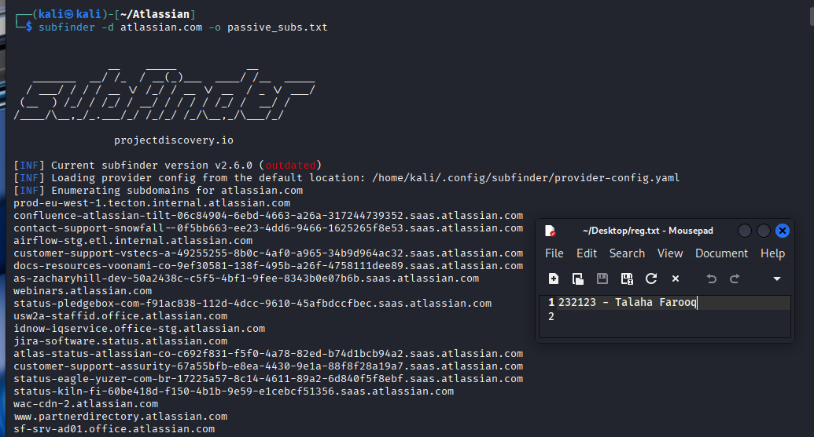
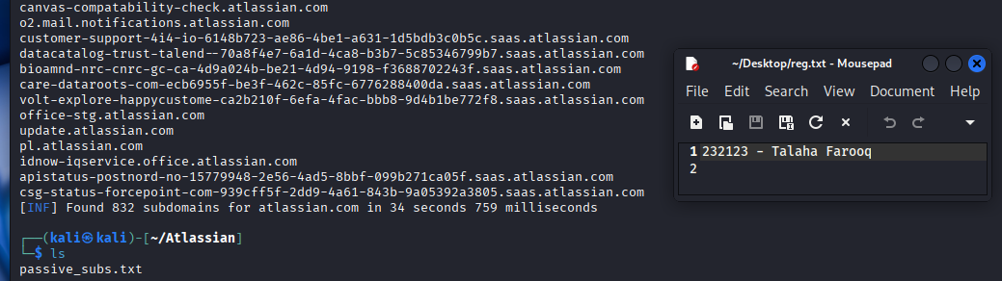

2.2 marketplace.atlassian.com
Host Discovery: Ping & Traceroute
Similar to admin.atlassian.com, this subdomain also resolves to a CloudFront CDN node, indicating use of AWS infrastructure for content delivery and origin masking.
Observations:
- The IP 13.227.180.4 corresponds to *.kix82.r.cloudfront.net
- Latency is higher than admin’s ping (average ~140 ms), but stable
- Traceroute passes through amazon.com backbone node (decix1.amazon.com), confirming regional AWS routing
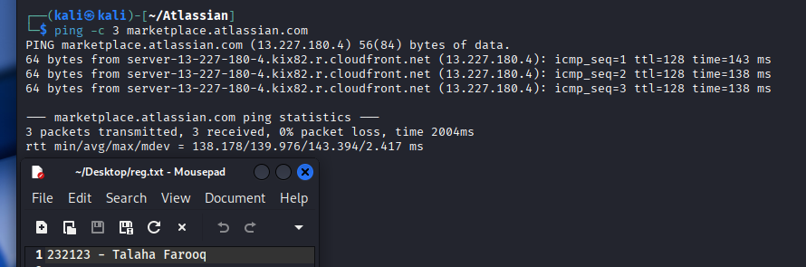
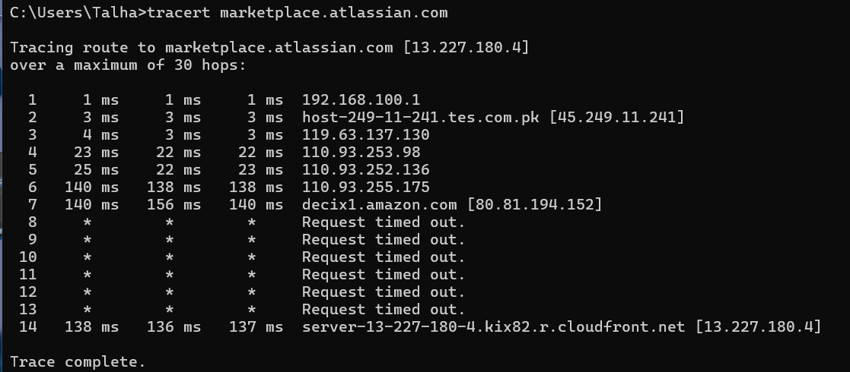
Subdomain Enumeration via Subfinder
subfinder was used to enumerate associated subdomains. Only a single subdomain was returned:
- status.marketplace.atlassian.com
Although not extensive, this still supports the use of status pages and third-party integrations that may be further explored (e.g., statuspage.io).
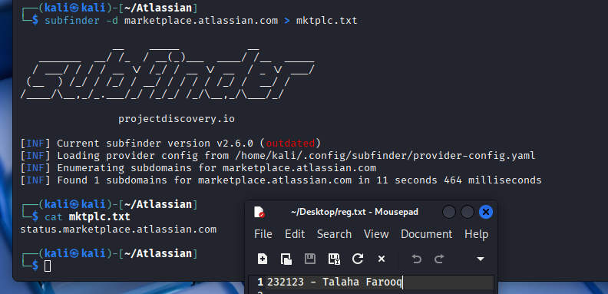

2.3 Bamboo.otiselevator.com
Host Discovery: Ping & Traceroute
Ping responses show a direct IP: 104.214.227.230, without obfuscation behind CDNs or proxy layers. Traceroute confirmed traffic passing through Microsoft Azure infrastructure (MSN ASN).
Observations:
- Stable ICMP latency ~196ms average.
- Hosting appears to terminate in Azure Europe (AMS).
- No CloudFront involvement like with admin or marketplace subdomains.
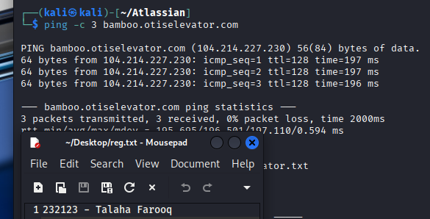
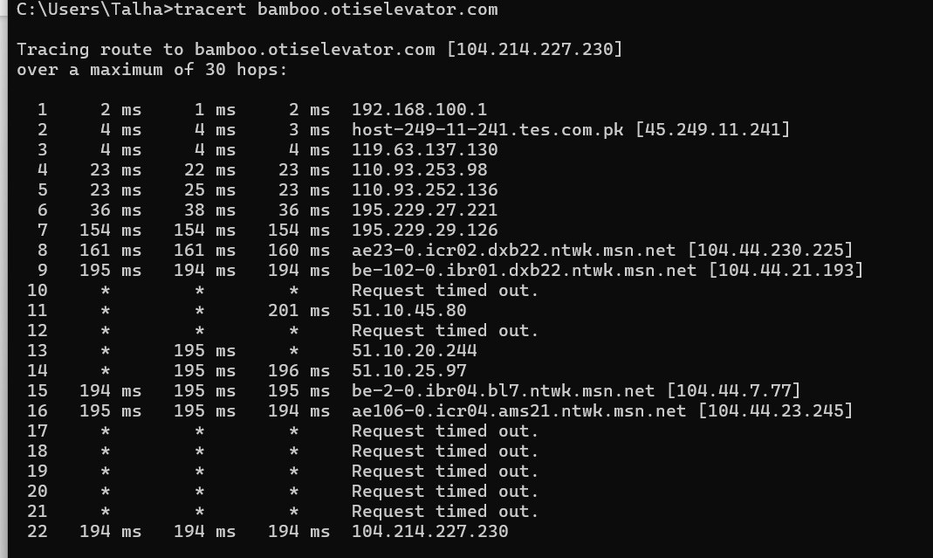
Subdomain Enumeration via Subfinder
Subfinder yielded 25 subdomains for otiselevator.com, including multiple environments like:
- dev, stg, qa, and prod versions of CI/CD pipelines
- jira.otiselevator.com, confluence.otiselevator.com
- Multi-region deployments (e.g., apac, emea, na, etc.)
This reveals a broad attack surface, especially for lateral movement or environment hopping (e.g., *.stag.otiselevator.com potentially being less monitored).
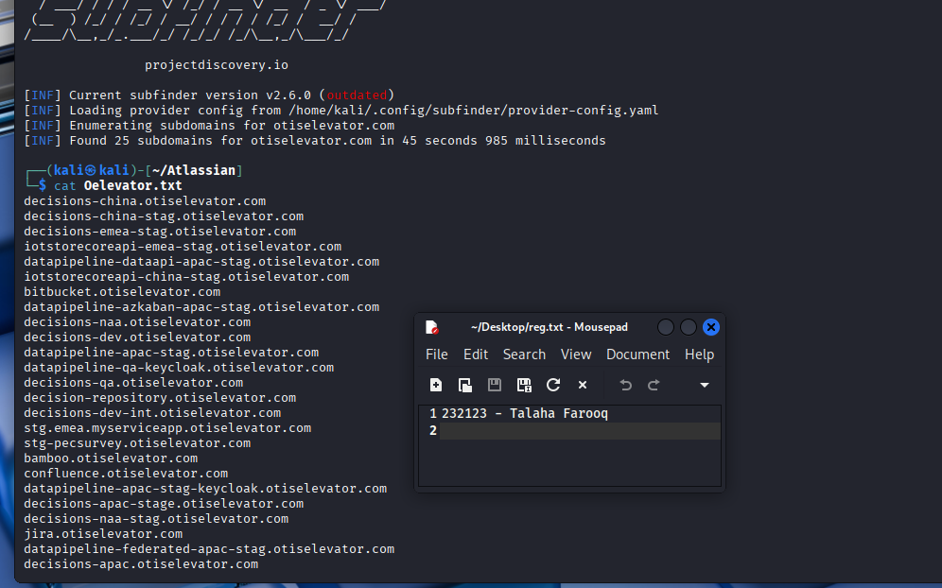

3. Host Discovery

3.1 Admin.atlassian.com
A basic TCP SYN scan was performed using Nmap to identify exposed ports and services.
Observations:
- The IP 143.204.106.82 resolved to server-143-204-106-82.mct50.r.cloudfront.net, confirming this subdomain is served behind CloudFront.
- Two open ports were identified:
  - 80/tcp: HTTP
  - 443/tcp: HTTPS
- Indicating aggressive firewalling or proxy/CDN-level filtering.
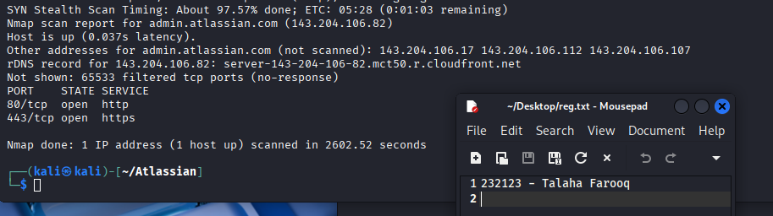

3.2 marketplace.atlassian.com
A similar TCP SYN scan was run on this subdomain to determine its externally exposed services.
Observations:
- IP: 13.227.180.4 → server-13-227-180-4.kix82.r.cloudfront.net
- Open ports:
  - 80/tcp: HTTP
  - 443/tcp: HTTPS
- CloudFront CDN confirmed again as the front-facing proxy.
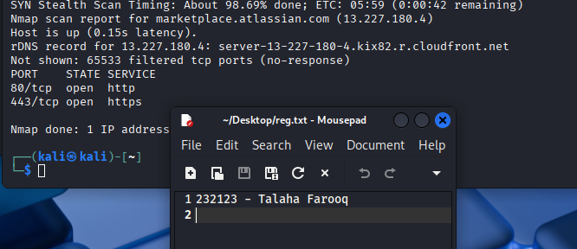

3.3 bamboo.otiselevator.com
A detailed TCP port scan was executed to identify accessible services on this non-standard Atlassian subdomain (hosted under Otis Elevator’s infrastructure).
Observations:
- IP: 104.214.227.230 (No CDN / proxy)
- Hosting environment suggests direct Azure-based exposure
- Open port:
  - 443/tcp: HTTPS
- Port 80 is closed (unlike admin & marketplace), reducing unnecessary attack surface
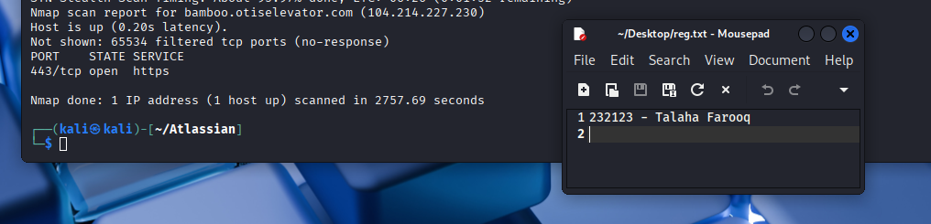

3.4 IP Fingerprinting
Tool: nmap -O -sS -Pn
Performed OS fingerprinting on direct A records from origin_finder.sh script:
- 3.165.102.39, 3.165.102.95, 3.165.102.104
  - OS Guesses: Linux 3.2–4.4, Windows XP SP3, VMware NAT, BlueArc Titan 2100 NAS
  - Ports: 80/tcp, 443/tcp open

Target | IP Address | Ports Open | Notes
admin.atlassian.com | 143.204.106.82 | 80, 443 | Cloudfront endpoint, OS detected via nmap
marketplace.atlassian.com | 13.227.180.4 | 80, 443 | Cloudfront, similar infra
bamboo.otiselevator.com | 104.214.227.230 | 443 | Hosted on msn.net infra
A-records (direct) | 3.165.102.x | 80, 443 | Fingerprinted, OS detection attempted

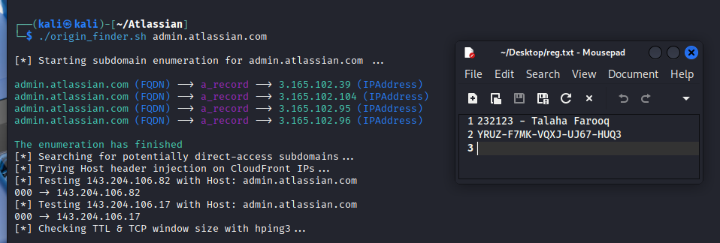
Operating System Distribution (Based on OS Fingerprinting)
From the cumulative results of the scanned IPs, the OS fingerprint confidence indicates the following dominant operating systems:
- Linux-based systems
  - Found in 100% of scanned IPs
  - Confidence scores range from 90% to 97%
  - Versions include Linux 2.4.37, 3.2, and 4.4
- Windows-based systems (XP SP3 / Server 2012)
  - Indicated in 3/3 scans
  - Confidence scores from 90% to 97%
- Virtualized NAT Environments (VMware)
  - Reported in 2/3 hosts
  - Confidence up to 96%
- Network-Attached Storage Devices (NAS)
  - BlueArc Titan 2100 NAS noted in 2/3 scans (85–90%)
Note: All OS detections were classified as "non-ideal" test conditions, meaning there’s a mix of environments behind load balancers (e.g., CloudFront), which may reduce detection accuracy.
The presence of both Linux and Windows OS fingerprints on the same IP ranges likely suggests:
- Use of cloud-based reverse proxies (e.g., AWS CloudFront)
- Virtualized hosting environments
- Possible multi-tenant architecture, complicating attribution of specific OS fingerprints
This distribution reflects cloud and legacy system coexistence, commonly seen in enterprise-grade SaaS infrastructure.

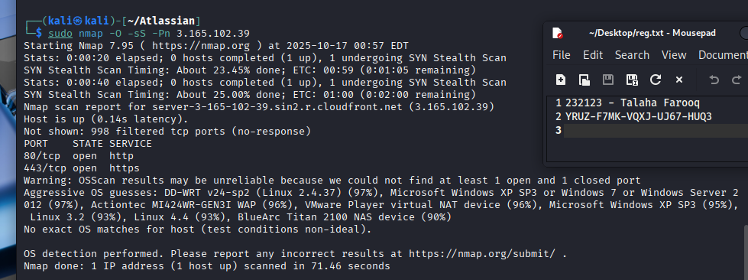
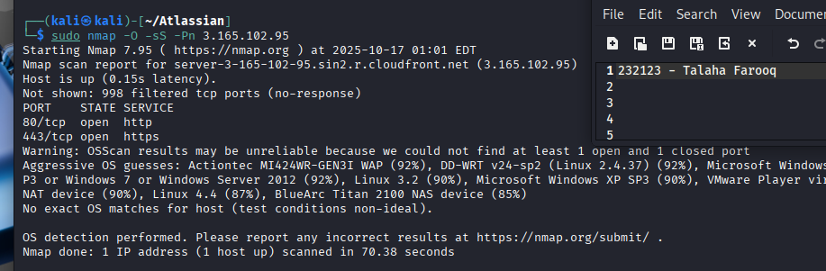
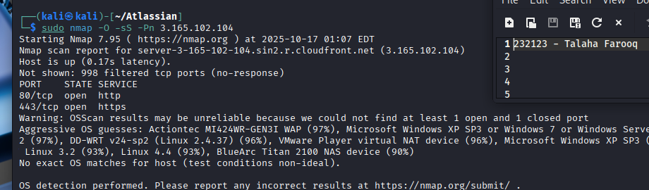

4. Asset Gathering

4.1 admin.atlassian.com
IP Ownership & Network Information
- IP Address Range: 143.204.0.0 – 143.204.255.255
- CIDR: /16
- NetName: AT-88-Z
- Allocated To: Amazon Technologies Inc.
- Country: United States
- Registry: ARIN (American Registry for Internet Numbers)
- Org Address:
410 Terry Ave N., Seattle, WA 98109, US
Administrative & Technical Contacts
- Org NOC:
  - Name: Amazon AWS Network Operations
  - Email: amzn-noc-contact@amazon.com
- Abuse Contact:
  - Name: Amazon EC2 Abuse
  - Email: trustandsafety@support.aws.com
- Routing & Management:
  - Routing Contact: aws-routing-poc@amazon.com
  - RPKI Management: aws-rpki-routing-poc@amazon.com
Observations
- The asset (admin.atlassian.com) is hosted within Amazon’s allocated address space under the AT-88-Z entity.
- Contact references and abuse details are clearly defined and verifiable via ARIN RDAP interface.
- This confirms Atlassian's reliance on AWS infrastructure for this subdomain, specifically routed through CloudFront CDN, as observed in earlier recon.
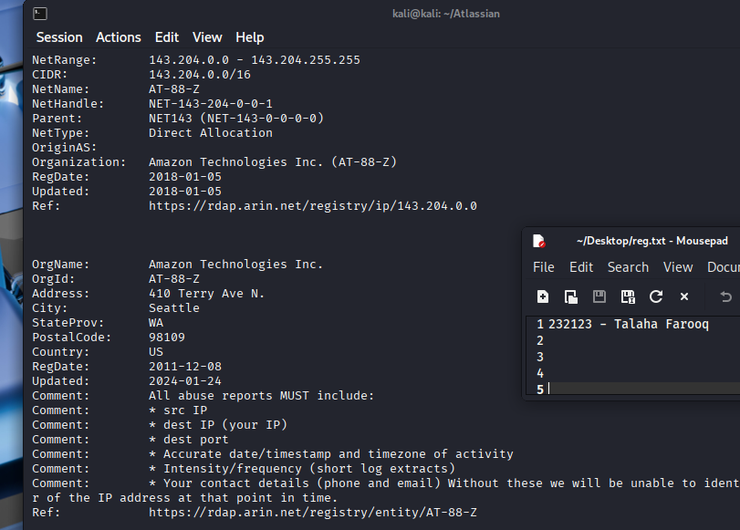
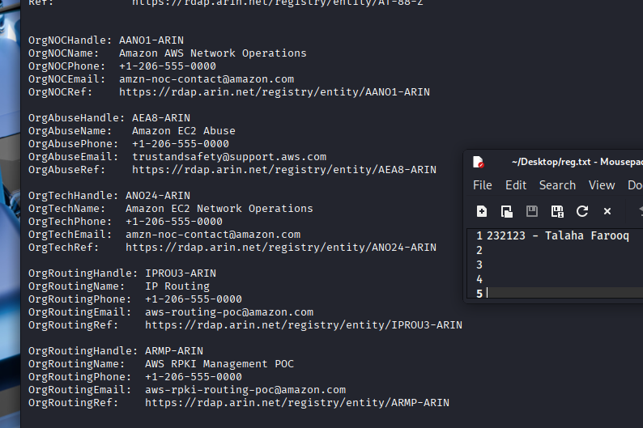

4.2 marketplace.atlassian.com
Registrar & Registrant Information:
- Organization: Amazon Technologies Inc. (AT-88-Z)
- Address: 410 Terry Ave N., Seattle, WA, 98109, United States
- Registered Since: 2011-12-08
- Last Updated: 2024-01-24
- Associated Registry Links:
  - IP Block: 13.200.0.0 - 13.239.255.255
  - Entity Reference: AT-88-Z
IP Information:
- NetRange: 13.200.0.0 – 13.239.255.255
- CIDR: 13.200.0.0/12 (includes 13.208.0.0/12 and 13.224.0.0/12)
- NetType: Direct Allocation
- Origin: Cloud infrastructure operated by Amazon AWS, indicating reliance on global CDN/distribution systems.
Operational Contacts:
- Technical Contact: amzn-noc-contact@amazon.com (Amazon EC2 Network Operations)
- Abuse Contact: trustandsafety@support.aws.com (Amazon EC2 Abuse)
- Routing Contact: aws-routing-poc@amazon.com
- Phone for All Depts: +1-206-555-0000
This information helps validate the authenticity and origin of the marketplace service infrastructure, suggesting the use of reliable and globally distributed cloud hosting via Amazon AWS.
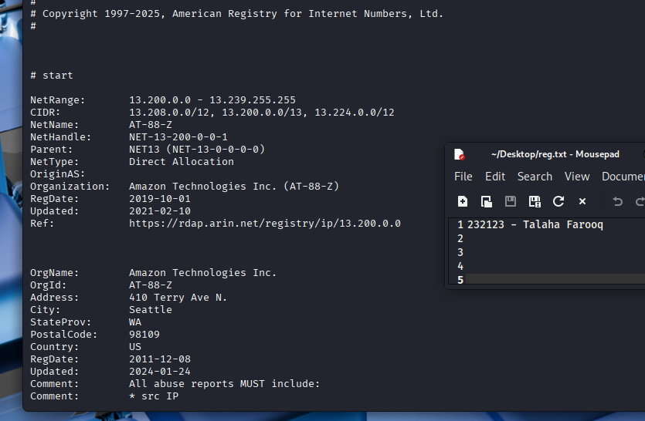
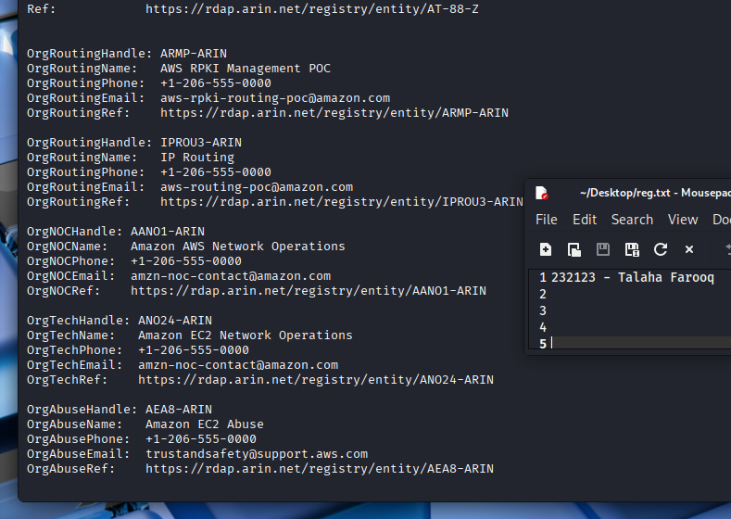

4.3 Bamboo.otiselevator.com
Domain Resolution and Ownership
The domain bamboo.otiselevator.com resolves to the IP address 104.214.227.230. A WHOIS lookup and RDAP query for this IP confirms that the address is registered under Microsoft Corporation (MSFT), indicating that this asset is hosted on Microsoft's infrastructure, most likely via Azure Cloud Services.
Registrant and Network Information
- Organization Name: Microsoft Corporation
- Org ID: MSFT
- Registered Address: One Microsoft Way, Redmond, WA, 98052, US
- NetRange: 104.208.0.0 – 104.215.255.255
- CIDR Blocks: 104.208.0.0/13
- NetHandle: NET-104-208-0-0-1
- NetType: Direct Allocation
- Updated On: 2021-12-14
- Registration Date: 2014-10-01
Contact Information
- Abuse Reports: abuse@microsoft.com
- Security Issues: secure@microsoft.com, https://cert.microsoft.com
- Legal & Law Enforcement: msndcc@microsoft.com
- Routing/DNS: IOC@microsoft.com
- Technical Contact:
  - Name: Dawn Bedard
  - Email: dabedard@microsoft.com
  - Phone: +1-425-538-6637
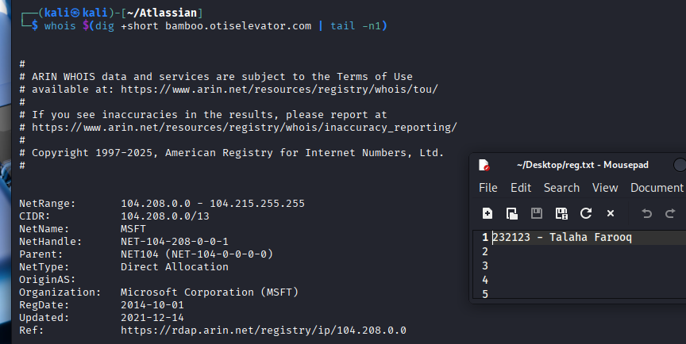
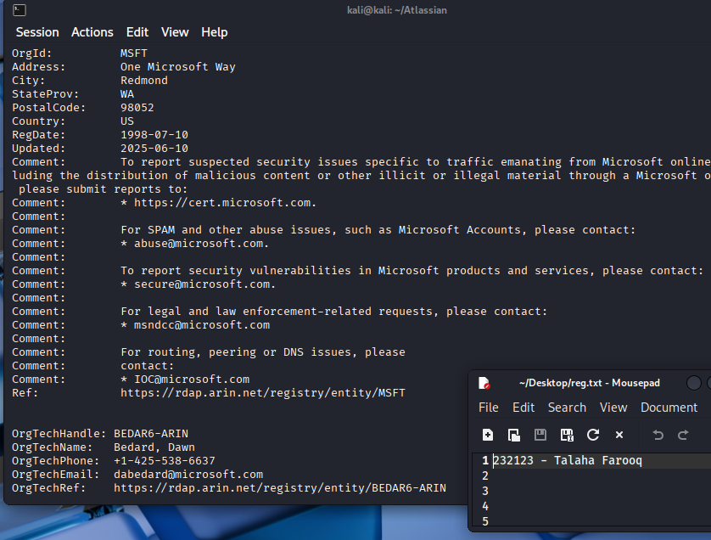

4.4 Assets (atlassian.com)
Tools & Methodology
- Tool Used: assetfinder
- Command: assetfinder --subs-only atlassian.com | tee -a all_atlassian_subs.txt
- Approach: Passive subdomain enumeration was conducted to gather publicly available DNS records related to the target domain.
Findings
A total of 40+ unique subdomains were discovered, indicating a broad and diverse attack surface. The assets are categorized below:
🔧 Administrative & API Endpoints
- admin.atlassian.com
- api.atlassian.com
- api-private.atlassian.com
- auth.atlassian.com
These are likely to be high-value targets during testing phases due to their role in authentication, backend logic, and administrative operations.
Product & Service Platforms
- confluence.atlassian.com
- automation.atlassian.com
- connect.atlassian.com
- cmp-forms.atlassian.com
- beta-developer.atlassian.com
These subdomains suggest customer-facing or beta environments, potentially vulnerable to exposure of business logic flaws, outdated frameworks, or insecure integrations.
Localized / Regional Assets
- cn.atlassian.com
- br.atlassian.com
- japan.blogs.atlassian.com
Indicates Atlassian’s regional presence, which might follow slightly different deployment cycles—useful during version-based vulnerability hunting.
Tracking / Analytics / Cookie Management
- usw2-track.atlassian.com
- atl-onetrust-wrapper.atlassian.com
These subdomains may host JavaScript files, third-party tracking services, or cookie banners, making them useful vectors for client-side vulnerabilities (XSS, misconfigurations).
Content & Developer Resources
- community.atlassian.com
- blogs.atlassian.com
- view.e.atlassian.com
- preferences.atlassian.com
- click.e.atlassian.com
Could host dynamic content such as blog posts, user-generated content, and email tracking—these are common candidates for stored XSS, open redirects, or template injection.
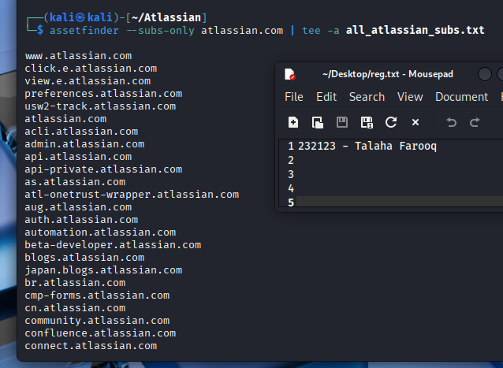

5. Scanning – all targets

5.1 Using nuclie scans
All Nuclei scans were executed using broad templates including misconfigurations, SSL checks, CSP issues, Atlassian-specific bugs, security.txt, and WAF detection.

5.1.1 admin.atlassian.com
This endpoint is hosted behind AWS CloudFront and heavily integrated with Atlassian’s public and internal infrastructure. The scan revealed several informational and low-severity issues.
- External Services & CDN Detection:
  - CloudFront WAF was detected.
  - Multiple AWS-related identifiers such as KMS, CloudFront service, and AWS service fingerprints were found.
- SSL/TLS Configuration:
  - TLS 1.2 and TLS 1.3 supported.
  - SSL issuer was Amazon.
  - Wildcard and SAN certs include many Atlassian-owned domains like bitbucket.org, trello.com, jira.com, etc.
- Security Headers – Missing:
  - x-permitted-cross-domain-policies
  - referrer-policy
  - clear-site-data
  - cross-origin-embedder-policy
  - cross-origin-opener-policy
  - cross-origin-resource-policy
  - permissions-policy
  - x-frame-options
  - These missing headers weaken the browser's ability to prevent cross-origin leaks, iframe abuse, and cache mismanagement.
- Interesting Endpoints:
  - Detected a Jira unauthenticated user picker at:
  - /secure/popups/UserPickerBrowser.jspa
Could assist in user enumeration in misconfigured setups.
- Other Metadata:
  - Presence of .well-known/security.txt with contact information: security@atlassian.com
  - Inclusion of deprecated XSS header: X-XSS-Protection: 1; mode=block
  - CAA DNS record detected confirming certification authority preference.
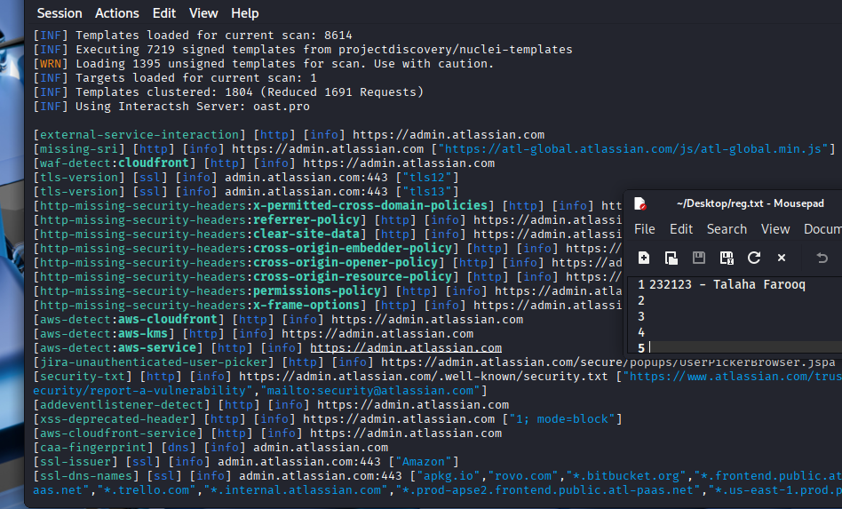

5.1.2 marketplace.atlassian.com
The Marketplace instance surfaced some notable issues, including potential API key exposure, lack of headers, and third-party analytics integrations.
- Potential Vulnerability – Credential Disclosure:
  - Two suspicious apiKey strings were found in the JavaScript responses, suggesting either exposed static tokens or API call remnants:
  - "apiKey": "1f5d5f93-c052-4372-bc81-a99b00e04bc0"
  - "apiKey": "3ef48f0fc67ee7e9c5a9dbbf6b45908c"
These should be manually validated to confirm if they are live, scope-limited, or environment/test keys.
- External Scripts Missing Subresource Integrity (SRI):
  - Multiple JS resources loaded from Optimizely, Atlassian CDN, and custom frontend bundles without SRI.
    - Could allow supply chain attacks if CDN is compromised.
- Metadata and Service Exposure:
  - Sitemap and robots.txt accessible
  - Use of Sentry logging service detected
  - CloudFront fingerprinted
  - TLS 1.2/1.3 enabled
  - Security contact in .well-known/security.txt confirmed
- Missing Headers:
  - content-security-policy
  - permissions-policy
  - x-permitted-cross-domain-policies
  - referrer-policy
  - clear-site-data
  - cross-origin-* family
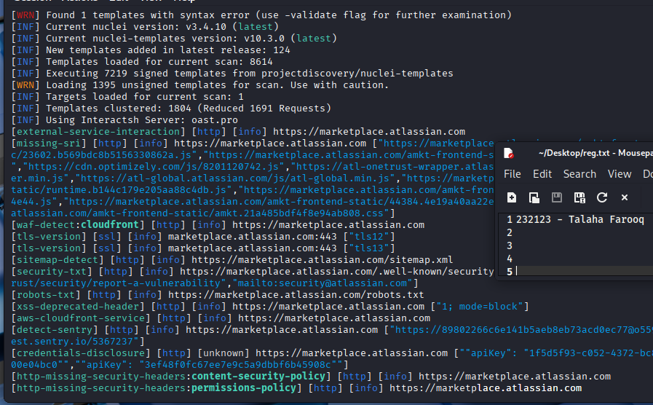

5.1.3 bamboo.otiselevator.com
This Bamboo instance is publicly exposed and revealed a combination of information disclosure, security header misconfigurations, and a version leak.
- Product Fingerprinting:
  - Atlassian Bamboo version 9.2.18 build 90217 was detected.
  - Login form endpoint:
  - /userlogin!doDefault.action?os_destination=%2Fstart.action
- Cookies Insecurely Configured:
  - JSESSIONID set without Secure or SameSite=Strict
  - atl.xsrf.token also lacks SameSite=Strict, increasing CSRF risks
- Headers Missing:
  - permissions-policy, referrer-policy, clear-site-data, cross-origin-resource-policy, etc.
  - Same missing headers found across all subdomains, suggesting a shared security baseline that lacks CSP hardening.
- Deprecated Headers:
  - X-XSS-Protection still in use, which is deprecated by modern browsers
- Stack Trace Exposure:
  - Potential low-severity issue detected via malformed query:
  - /?f=\[
May trigger a Tomcat stacktrace, useful for internal path or version leakage.
- SSL/TLS Info:
  - TLS 1.2 and 1.3 supported
  - Issued by Entrust
  - Includes both bamboo.otiselevator.com and www.bamboo.otiselevator.com
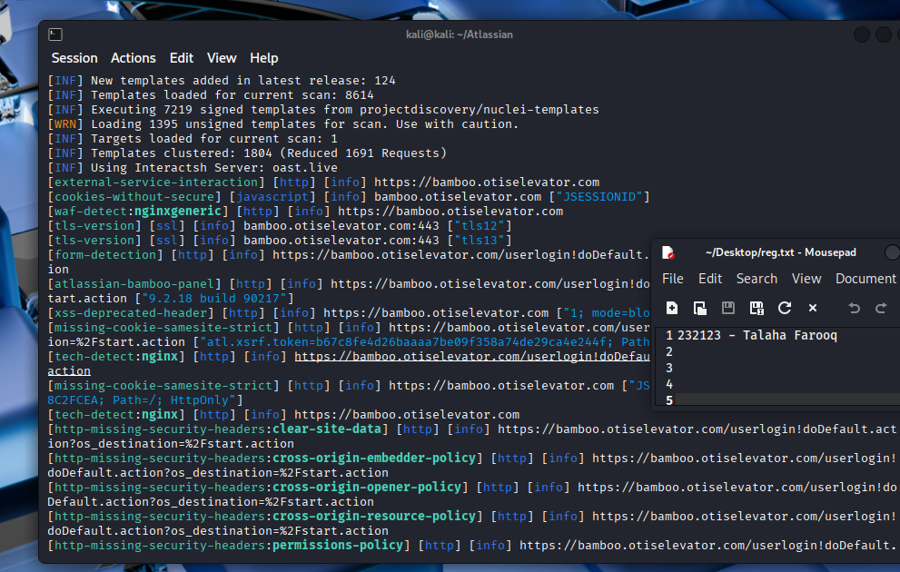

5.2 Using nikto scans
Nikto v2.5.0 was used to passively scan the HTTPS endpoints of the Atlassian assets to detect known vulnerabilities, misconfigurations, and sensitive files. While no high-risk issues were found, several informational and misconfiguration-based warnings were logged.
Note: nikto scan on bamboo site returned no results.

5.2.1 admin.atlassian.com
The Nikto scan against the admin interface yielded multiple uncommon headers, missing protections, and exposed file endpoints.
Notable Issues & Observations:
- Security Headers Missing:
  - X-Frame-Options – absence increases risk of clickjacking
  - X-Content-Type-Options – could allow MIME-sniffing attacks
- Sensitive Files Detected:
  - /adminatlassian.cer: A certificate-like file that could hint at a leaked cert or backup (CWE-530)
  - /com.tgz: Possibly a backup tarball; may contain sensitive configuration or source code
- Uncommon/Internal Headers Logged:
  - x-b3-traceid, x-b3-spanid, atl-traceid, x-cache-status: HIT, x-b3-sampled
  - server-timing exposed upstream trace details including region: aws-ap-south-1
  - reporting-endpoints defined for CSP violations and crash reports
- Cloud Infrastructure Fingerprint:
  - Server banner changed from AtlassianEdge to CloudFront mid-request, confirming CloudFront usage
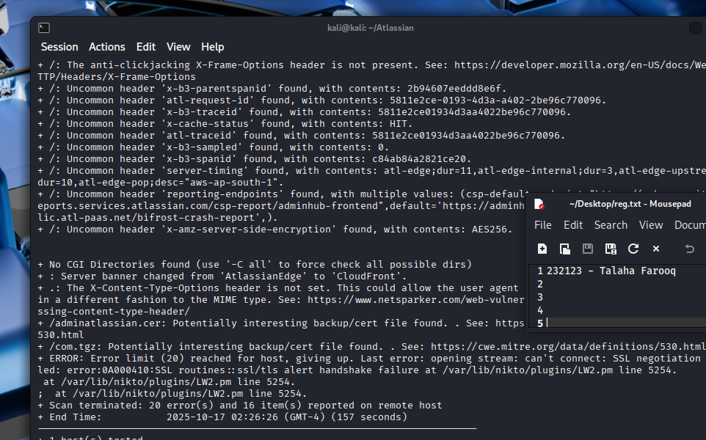

5.2.1 marketplace.atlassian.com
Notable Issues & Observations:
- Missing Security Header:
  - X-Content-Type-Options also not set here
- Potential BREACH Attack Risk:
  - Content-Encoding: deflate detected — compressible response body + reflected content could be abused in TLS-based BREACH attack scenarios
- Access-Control Header:
  - Access-Control-Allow-Origin: * – indicates open CORS policy, which might expose API responses to third-party sites if not properly scoped
- Robots.txt Content:
  - 7 disallowed paths found; suggested manual review (e.g., admin paths, staging, dev)
- Uncommon Headers:
  - server-timing, atl-request-id, atl-traceid, and x-cache-status: CACHEABLE
- CDN Fingerprint:
  - Initial banner AtlassianEdge swapped to CloudFront, indicating request routing through AWS infrastructure
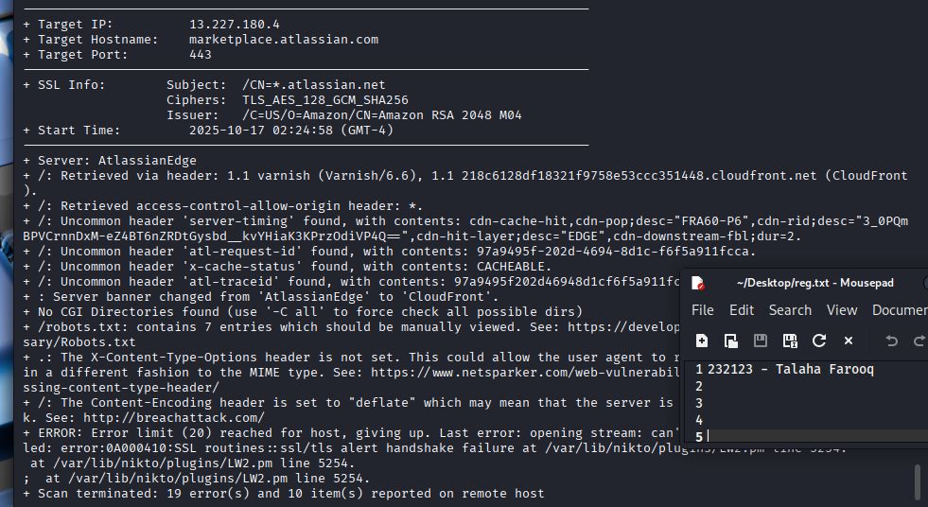

5.3 Comparison
Category | Tool | admin.atlassian.com Findings | marketplace.atlassian.com Findings
Security Headers | Nuclei | Missing: CSP, COOP, COEP, CORP, Referrer, Permissions, XFO | Missing: CSP, Permissions, Referrer, CORP, Clear-Site-Data
 | Nikto | Missing: X-Frame-Options, X-Content-Type-Options | Missing: X-Content-Type-Options
Sensitive File Exposure | Nuclei | .well-known/security.txt exposed (expected, informational) | .well-known/security.txt exposed
 | Nikto | /adminatlassian.cer, /com.tgz detected as possibly sensitive | No sensitive files flagged
Product/Service Fingerprints | Nuclei | AWS CloudFront, KMS, S3, WAF identifiers, CDN fingerprinted | Sentry logging, Optimizely JS, API key strings in JS
 | Nikto | Identified CDN (CloudFront), AtlassianEdge headers | Same: AtlassianEdge → CloudFront switch detected
Cookie Security | Nuclei | Weak/missing flags on session cookies (e.g., SameSite, Secure) | Not explicitly flagged
 | Nikto | Not analyzed | Not analyzed
Deprecated/Weak Headers | Nuclei | Deprecated X-XSS-Protection used | Same
 | Nikto | Not highlighted | Not highlighted
API/Data Exposure | Nuclei | Unauthenticated Jira UserPicker endpoint | Two unverified API keys found in JS files
 | Nikto | Not detected | Not detected
CORS Policy Check | Nuclei | Not detected | Open CORS policy (Access-Control-Allow-Origin: *)
 | Nikto | Not highlighted | Open CORS also observed
TLS/SSL Configuration | Nuclei | TLS 1.2 & 1.3 supported; wildcard cert; many SANs | Same; certs from Amazon
 | Nikto | Deflate compression flagged (BREACH risk) | Deflate compression flagged

6. Directory Bruteforcing
Directory and file brute-forcing was conducted using FFUF with the common.txt wordlist from SecLists. Each target was fuzzed using a tailored configuration to identify hidden files, misconfigured endpoints, and sensitive internal paths.
admin.atlassian.com
This endpoint responded to several brute-force probes with successful HTTP 200 responses, indicating the presence of potentially exposed sensitive files:
- /.hta, /.htaccess, and /.git/config: All returned 200 OK, suggesting these paths may either be exposed intentionally for deception or are mistakenly accessible.
- /.bashrc and /.env: Returned content-length indicative of actual file presence; these files often contain environment variables or shell configurations.
- Risk: These types of files, if not properly protected, could expose credentials, API keys, or configuration paths.
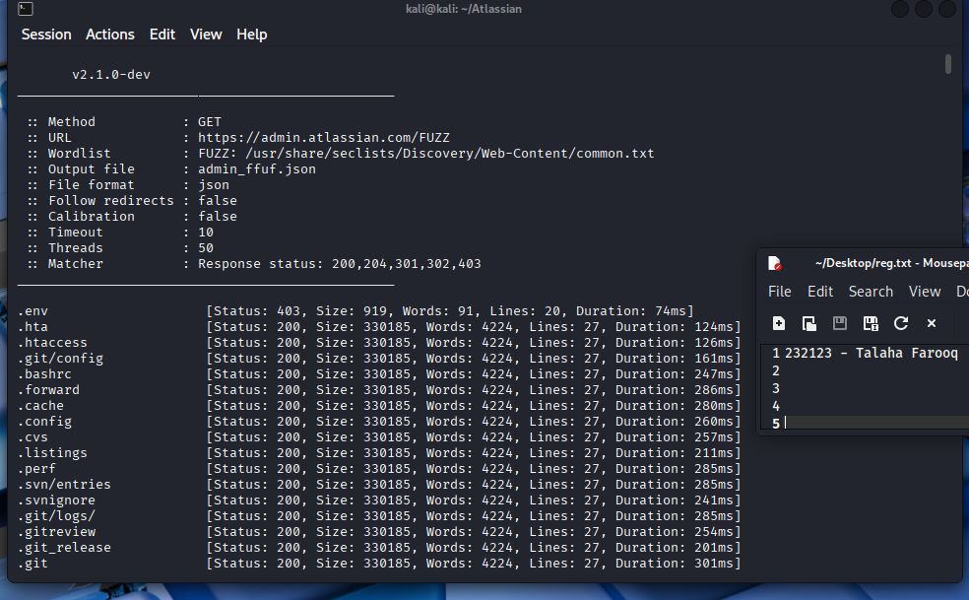
marketplace.atlassian.com
While less revealing than the admin interface, this subdomain returned multiple 403 Forbidden responses, confirming the existence of restricted files:
- Probed paths included common misconfigurations like /.git/, .env, .htaccess, etc.
- These 403s, while not exposing content, affirm that the resources exist and are protected, which could help guide timing-based or cache probing attacks in future assessments.
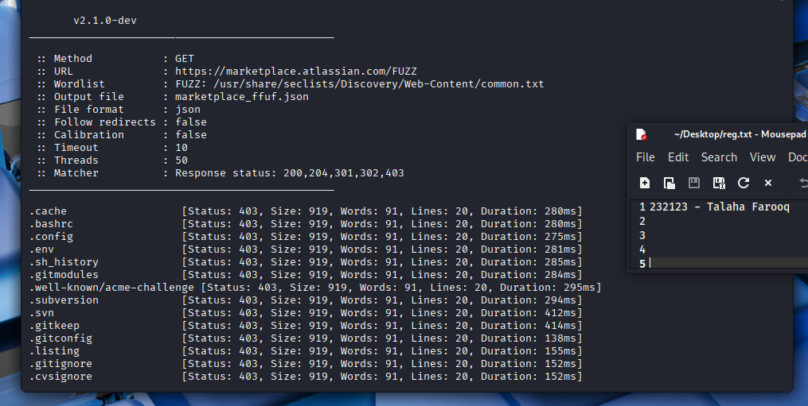
bamboo.otiselevator.com
Only two meaningful responses were returned:
- /browse: Returned a 302 redirect to the login page, confirming the path’s availability and protected nature.
- /captcha: Returned 200 OK with a JPEG, suggesting this is part of the login form mechanism. This is likely used to prevent automated brute-force attacks, but may itself be tested for bypass methods later.
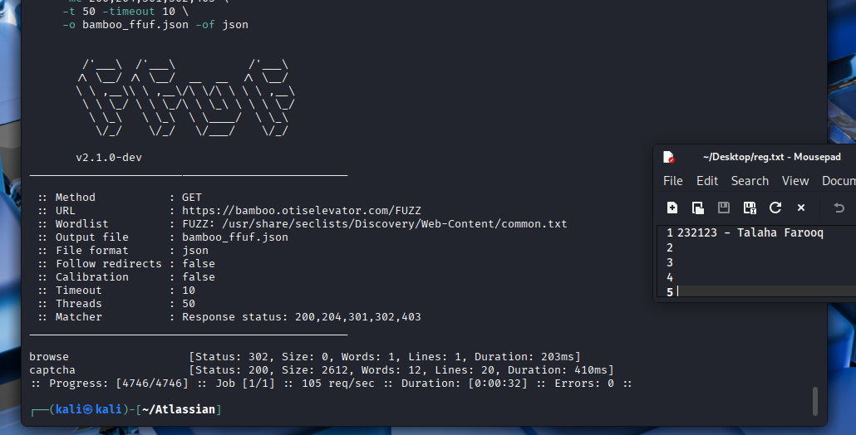
Target | Interesting Paths Found | Risk Level | Notes
admin.atlassian.com | .git/config, .bashrc, .env, .htaccess | High | 200 OK responses; content accessible
marketplace.atlassian.com | .env, .htaccess, .git/ | Medium (403) | Existence confirmed, but access denied
bamboo.otiselevator.com | /browse, /captcha | Low | Login-protected content; CAPTCHA present

7. Technology Detection
admin.atlassian.com
- HTTP Status: 200 OK
- IP Address: 143.204.106.82
- Country: United States
- Server: AtlassianEdge
- Technologies Identified:
  - HTML5
  - Strict-Transport-Security header with long max-age (63072000)
  - JavaScript modules (via content-type analysis)
  - Security Headers:
    - X-Content-Type-Options
    - X-XSS-Protection
    - Strict-Transport-Security
    - Content-Security-Policy variants
  - CDN: Amazon CloudFront
- Title Detected: Administration
- Additional Indicators:
  - Host operates behind a proxy (CloudFront)
  - Uses custom Atlassian infrastructure
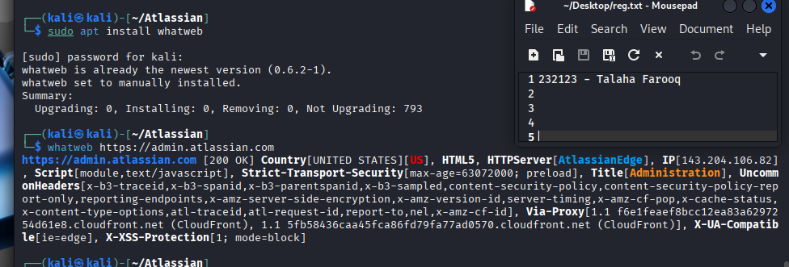
marketplace.atlassian.com
- HTTP Status: 403 Forbidden
- IP Address: 13.227.180.4
- Country: United States
- Server: CloudFront
- Technologies Identified:
  - Strict-Transport-Security (high max-age: 31536000)
  - X-Frame-Options: DENY
  - X-XSS-Protection: enabled with mode block
  - Security via CloudFront (Amazon CDN)
- Title Detected: ERROR: The request could not be satisfied
- Access: Appears restricted behind a WAF or CDN-level access control
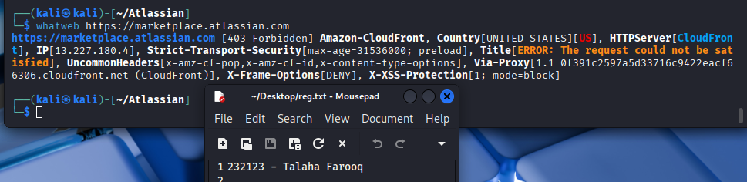
bamboo.otiselevator.com
- HTTP Status: 302 Found (Redirect)
- IP Address: 104.214.227.230
- Country: RESERVED (likely redacted due to IP privacy via cloud)
- Server: nginx
- Technologies Identified:
  - Java Backend (inferred from redirect path containing doLogin!dodefault.action)
  - Session Handling: Cookies (JSESSIONID)
  - Security Headers:
    - Strict-Transport-Security
    - X-Frame-Options
    - X-XSS-Protection
    - Content-Security-Policy
- Redirect Location: Indicates a Java-based application server, likely Apache Struts or similar
- Framework Indicators:
  - Redirect path pattern suggests possible use of Atlassian Bamboo, which commonly runs on Java
All three targets use strong security headers, and are likely deployed behind CloudFront or similar CDN/proxy solutions.
bamboo.otiselevator.com demonstrates a Java-based enterprise environment behind nginx, while admin.atlassian.com and marketplace.atlassian.com are built with modern web stacks, supported by Amazon's infrastructure.
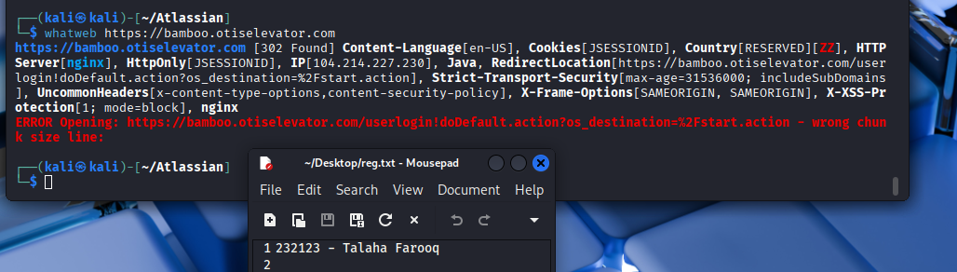

8. Parameter Gathering
During reconnaissance and enumeration, a variety of GET parameters were identified across multiple endpoints. These parameters, discovered through tools and passive inspection, provide potential vectors for testing authorization controls, input validation, and contextual data leaks.
1. admin.atlassian.com
This domain exposed a rich set of URL parameters suggesting heavy client-side routing and API-backed user management. The parameters uncovered appear in contexts ranging from billing flows to organization/user management dashboards.
Observed Parameter Categories:
- Status and Filters:
  - status, activeStatus, activeFilter, filter, memberState
  - Often used in users, members, and access-requests endpoints.
  - These are likely used for toggling between user states (active, inactive, pending).
- Entity Identifiers:
  - userId, productId, orgId, workspaceAri, domain
  - Present in access requests, billing, and organization configuration APIs.
  - Could be interesting for IDOR testing or tenant separation validation.
- Search and Navigation:
  - searchText, referrerName, displayName, page, start-index
  - Used for filtering user lists or paginating API responses.
- Feature & Routing Control:
  - src, referrer, utm_type, utm_identifier, grantAccessTo, selected
  - These parameters appear in billing and navigation URLs and may influence the flow of internal processes or render states.
- API-specific:
  - Parameters in paths like /gateway/api/post-office/api/v1/placements/... show:
    - locale, product, subproduct, workspaceAri, updateKey
    - Suggest a backend-driven UI rendering mechanism, useful for logic testing.
Sample Paths With Parameters:
https://admin.atlassian.com/s/{workspace}/users?activeStatus=FUZZ
https://admin.atlassian.com/s/{workspace}/access-requests?userId=FUZZ&productId=FUZZ
https://admin.atlassian.com/gateway/api/post-office/api/v1/placements/...&orgId=FUZZ
These endpoints reveal a multi-tenant architecture where tenant and user isolation testing (e.g., IDOR or path traversal) is critical.
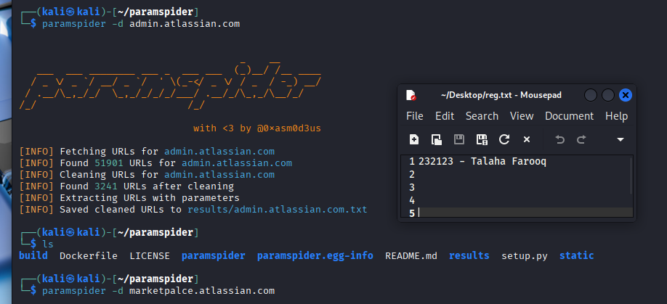
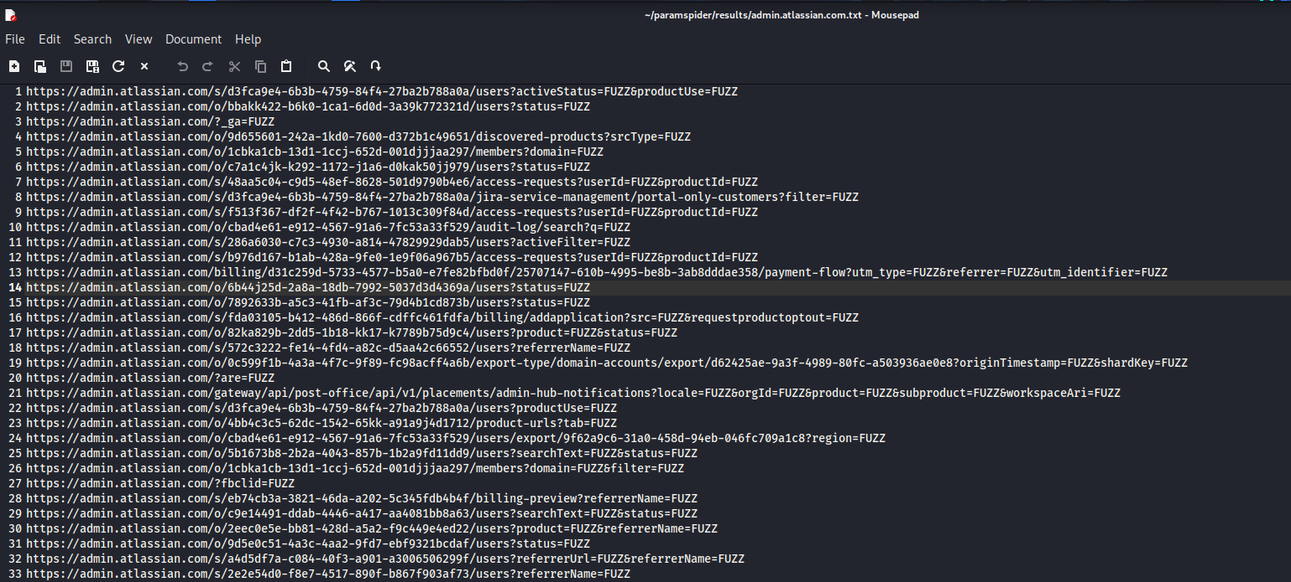
2. marketplace.atlassian.com
Fewer parameterized paths were found here, but a few were noteworthy due to their potential use in filtering, analytics, or user interaction flows.
Observed Parameter Types:
- Search Parameters:
  - query, category, label, sort
  - Found in URLs related to listing Atlassian apps or plugins.
  - These are strong candidates for XSS, filter bypass, or open redirect testing if mishandled.
- Tracking Parameters:
  - utm_source, utm_medium, utm_campaign
  - Commonly used for marketing tracking, but may influence redirect logic.
Example Path:
https://marketplace.atlassian.com/search?query=FUZZ&label=FUZZ&category=FUZZ
While limited in exposure, these parameters still merit testing for client-side injection or redirect-based logic abuse.
- admin.atlassian.com offers a significantly broader attack surface due to its dynamic user and org-level routes, exposing dozens of parameters related to access control, billing, membership, and navigation logic.
- marketplace.atlassian.com provides a smaller set of user-facing parameters mainly suitable for testing client-side injection vectors.
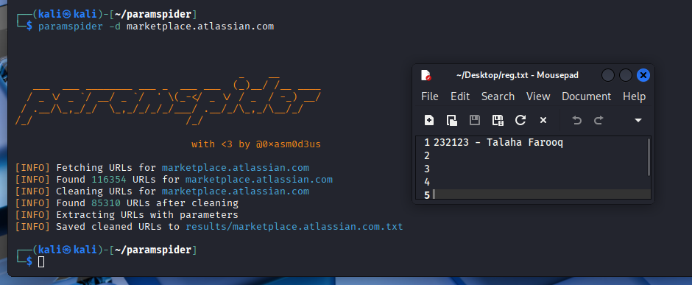
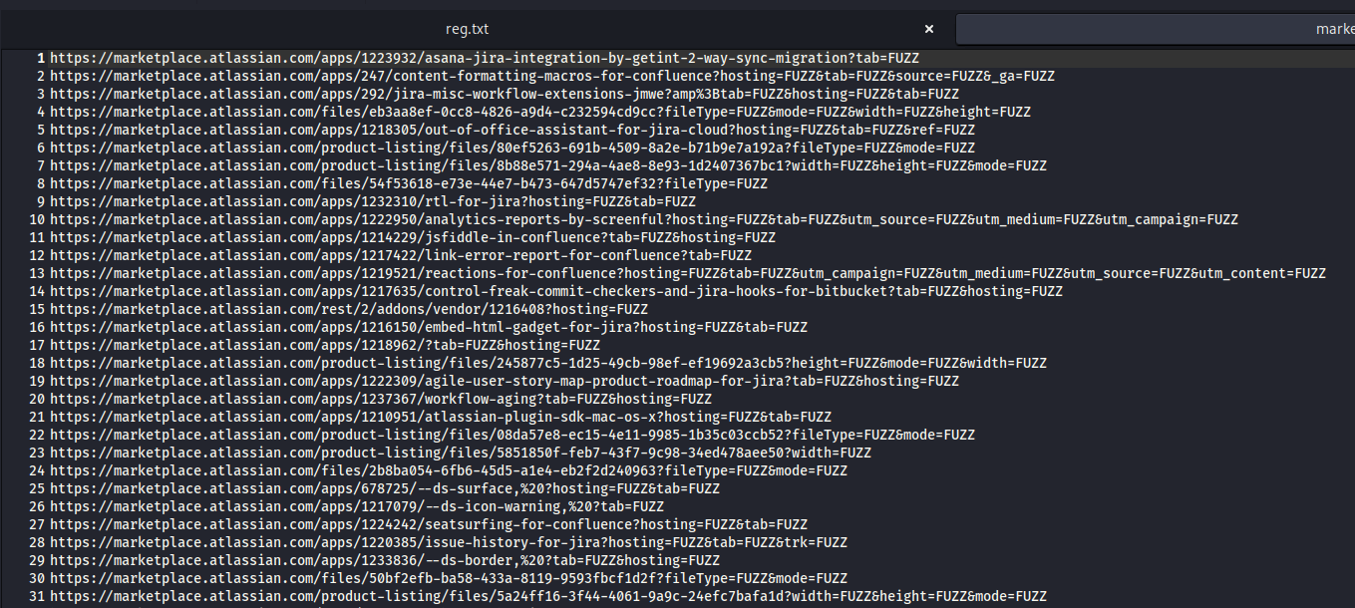
Note: I did not consider bamboo site as it is low priority site and a partner site so parameter gathering was well suited for the sites mentioned above

9. Firewall Technology
The Web Application Firewall (WAF) fingerprinting was conducted using the wafw00f tool to identify the protection mechanisms in place on each target domain. The results are as follows:
1. admin.atlassian.com
- WAF Detected: Cloudfront (Amazon)
- Details:
Amazon CloudFront acts as a content delivery network and WAF, offering rate-limiting, bot mitigation, and filtering capabilities. This suggests that the admin portal is protected against common web attacks such as:
  - SQL Injection
  - Cross-site Scripting (XSS)
  - DDoS attacks
- WAF Tool: wafw00f v2.3.1
- Number of Requests Made: 2
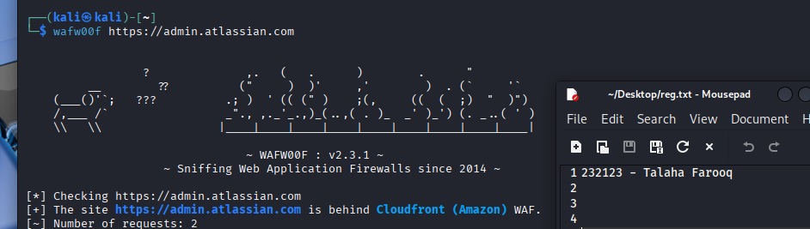
2. marketplace.atlassian.com
- WAF Detected: CacheWall (Varnish)
- Details:
CacheWall is a Varnish-based WAF that emphasizes performance and caching but also provides basic web attack filtering. Detection of error patterns (403, 404, 405, 500, 502) confirms filtering is active. It likely protects against:
  - Unauthorized access attempts
  - Protocol/Method misuse
  - Malformed requests
- WAF Tool: wafw00f v2.3.1
- Number of Requests Made: 2
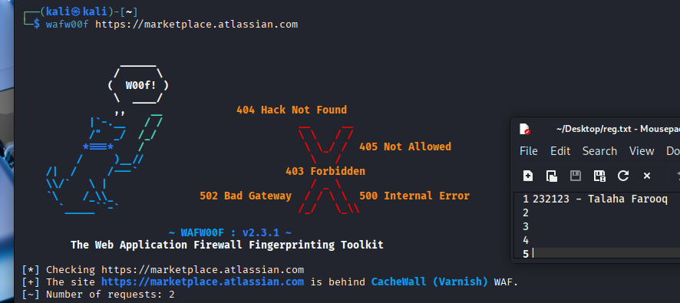

Conclusion
This assessment focused on three primary targets—admin.atlassian.com, marketplace.atlassian.com, and bamboo.otiselevator.com—using a full reconnaissance and scanning methodology spanning passive intel, active probing, host fingerprinting, asset mapping, and vulnerability scanning.
The two Atlassian domains were found to be hosted behind Amazon CloudFront, using robust TLS configurations and modern cloud-native infrastructure. However, despite the strong hosting environment, both exposed several misconfigurations such as missing security headers, potential API key disclosures, and publicly accessible sensitive files. Particularly, admin.atlassian.com revealed high-risk endpoints like exposed .git/config, .env, and user enumeration vectors via Jira. The presence of unauthenticated parameters related to users, billing, and org management introduces a sizable attack surface for IDOR and logic flaw testing.
Marketplace.atlassian.com also exhibited minor exposures including open CORS policy, lack of SRI in external scripts, and potential API key remnants in JavaScript—worth deeper investigation.
Meanwhile, the third-party subdomain bamboo.otiselevator.com, hosted on Microsoft Azure, exposed an Atlassian Bamboo instance with weak cookie flags, version disclosure, and possible stack trace leaks. Though lower in priority, it still reflects security gaps in partner infrastructure.
Across all targets, security header hardening, cookie flag enforcement, and tightening endpoint exposures remain critical. The overall environment leverages strong cloud foundations but shows inconsistent implementation of defensive controls, which, if addressed, can significantly reduce attack surface and improve resilience against common web threats.

